FINGER IDENTIFIER

**AVIRAT GUPTA**

**JC BOSE UST, YMCA**

**4th August,2020**

ABSTRACT

Finger detection is an interesting topic to explore in image processing, especially when it is applied in human-computer interaction. Finger detection is one of the popular minor projects in recent times. Finger detection has an accuracy similar to human brain to detect fingers. Fingers can be detected from different positions from front and from back side and at different angles. It might be of different shades , contrast and color.

On the other hand, some fingers are highly confusing to predict if they overlaps or in the same row. Therefore, perfect detection of fingers can be difficult.

INTRODUCTION

It is a minor project in which we are training our dataset model. The goal of the project is to build a model which is able to count fingers displaying in the image.we present a deep learning model which is used for counting finger and estimate number. We first train our model .This type of pretraining is tested on our baseline model and two methods of pre-training are compared. The network is extended to produce finger counting . The performance in number estimation of such an extended model is evaluated. The results confirm the importance of training in our enumeration task and show some similarities to human behaviour in the case of subitizing.

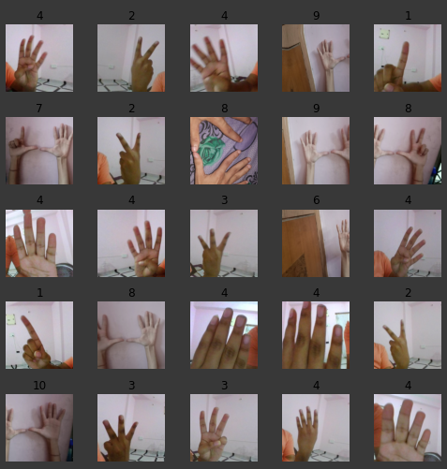

KEYWORDS

1. DEEP LEARNING
2. FINGER RECOGNITION
3. DATASET
4. KAGGLE
5. Fastai
6. ImageDataBunch
7. CNN_LEARNER
8. FIT_ONE_CYCLE
9. EPOCH

10.MAKEDIRS

11.MKDIR

12.EXPORT.PKL

13.STAGE-1.PTH

14. PREDICT

TECHNICAL THINGS USED IN PROJECT

1. We are using kaggle to import dataset which we are using in our project.

To download the required dataset by copying API from kaggle and run in google colab cell. We use ! in google colab to execute any command.

**!kaggle datasets download –d aviratgupta/identifyfingers**

1. We are using fastai, pandas and warning library in our project.
2. Initialising batch size as 64.Batch size is a term used in deep learning and refers to the number of training examples utilized in one iteration .
3. The most important functions of this module are cnn_learner.  They will help you define a Learner using a pretrained model.
4. We are using resnet50 in our model. It  is a convolutional neural network that is 50 layers deep. You can load a pretrained version of the network trained on more than a million images from the ImageNet database [1]. The pretrained network can classify images into 1000 object categories, such as keyboard, mouse, pencil, and many animals.here we are using fingers as object.
5. We are using cv2 library to create a video of our trained data .
6. **Training accuracy per epochs.**

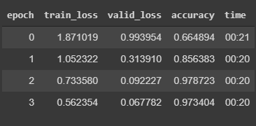

1. **Confused matrix.**

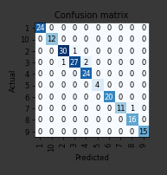

1. **Some of the predicted output:-**

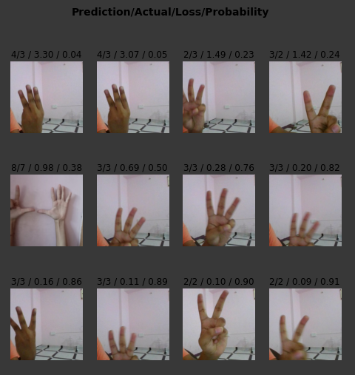

Conclusion

In this project, we have imported our dataset to the google colab notebook from kaggle. There are various type of libraries used in the project which is very helpful for the implementation and make the project reliable and easy. Training the model is the most important and time taking part. After training, we have to save our file in export.pkl file in google drive which contains all our trained data.

Prediction of the data is the important part in our project. After the prediction, we will create a video of our trained and predicted data which will help us to see machine’s prediction in a video.

This project helps me to understand various topics on deep learning. It gave us a base to perform multiple task in future.

REFERENCE

* Stackoverflow
* Github
* Kaggle
* Google colab
* Fast.ai
* Various other sites.

ACKNOWLEDGEMENT

This project is made possible through the help and support from everyone including: parents, teachers and classmates,friends and in essence ,all sentient beings.Especially ,please allow me to dedicate my acknowledgement of gratitude towards the following significant advisors and contributors:

First and foremost, I would like to thank GOD for his unconditional guidance and wisdom as I make my research.

Second,I would like to thank our instructor Mr. Trilok sir for the support and encouragement. This gives us experience on how to cooperate and engage ourselves in projects.

Finally, I sincerely thank to my parent , family and friends .The product of this research paper would not be possible without all of them.